1. While you are performing an air reduction of intussusception in a 1 y/o, the patient develops tachycardia and tachyphnea. You identify pneumoperitoneum. You should (circle all that are correct):

1. Promptly decrease insufflation pressure
2. Promptly increase insufflation pressure
3. Stick a needle in the child’s abdomen
4. Switch to using liquid for reduction

2. The following are contraindications to immediate reduction (circle all that apply)

1. The patient has been ill for over 48 hours
2. There is free fluid on ultrasound
3. Stool is frankly bloody
4. The patient is listless
5. The patient is hypotensive

3. When using air to reduce intussusception, the standard accepted maximum pressure is:

1. 80 mmHg
2. 100 mmHg
3. 120 mmHg
4. 140 mmHg

4. You are shown the following image.

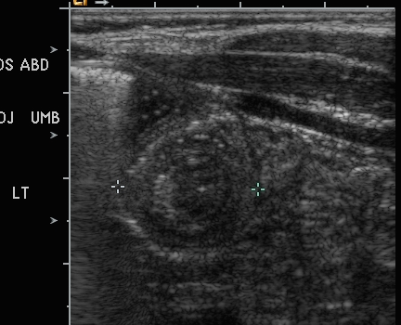

The appropriate next step is to:

1. Contact surgery and perform intussusception reduction
2. Contact surgery and recommend emergent surgery
3. Contact surgery and report the patient has intussusception but that no intervention is indicated
4. Stick a needle in the child’s abdomen

5. Lead points are more likely if the patient is (circle all that apply)

1. Younger than 2 months
2. Younger than 5 months
3. Older than 1.5 years
4. Older than 5 years

6. Common lead points include everything except

1. Lymphangioma
2. Bowel duplication
3. Appendicitis
4. Meckel diverticulum
5. Lymphoma

7. You have been applying maximum pressure for two minutes and the intussusceptum hasn’t moved. What should you do?

1. Release the pressure and try again
2. Release the pressure and send the patient to the OR
3. Increase the pressure
4. Keep applying pressure

8. You just started reducing an intussusception, and obtained this image:

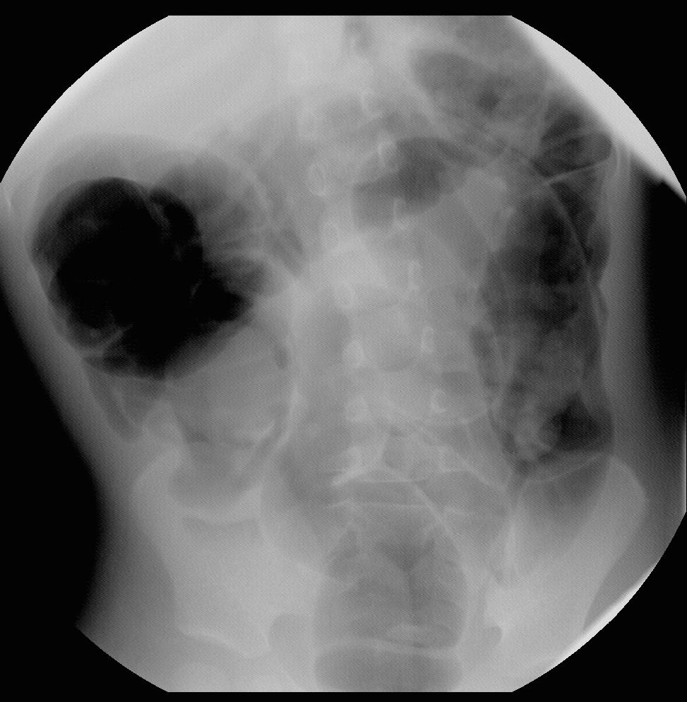

What should you do?

1. Continue the procedure
2. Send the patient to the OR
3. Send the patient home
4. Ask the surgeons to admit the patient for monitoring